Lab: Subtypes

Overview

In this lab you will continue to modify the base data model. The focus is on modifying an existing subtype and adding a new subtype.

Tasks

1. First, create an extension of the ABLegalVenue entity subtype (HINT – by default, ABLegalVenue appears in /configuration/config/metadata/entity and cannot be altered. You can create an entity extension either directly from the existing subtype or directly in the /configuration/config/extensions/entity folder.
   1. The following screenshot shows how to create an editable entity extension based on ABLegalVenue in the metadata folder. The newly created extension appears in /configuration/config/extensions/entity.

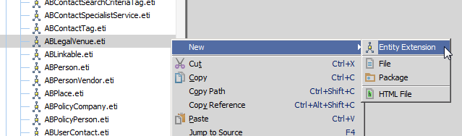

* 1. Enter a Filename Suffix at the prompt as follows.

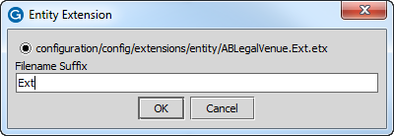

1. Add the following information to the ABLegalVenue entity extension.

* HoursOfOperation_Ext (A string of up to 40 characters)
* OpenForNightCourt_Ext (A boolean)

1. Create a new subtype for property inspectors called ABPropInspector_Ext. It should have supertype ABVendorPerson. Be sure to create the new subtype entity in /configuration/config/extensions/entity.

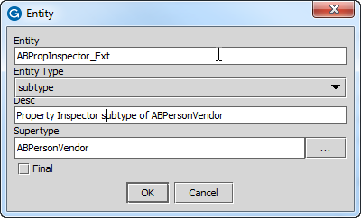

1. The new subtype fields include the following information. Unless noted otherwise, null values are acceptable.

* InspectorLicense (A string up to 40 character)
* HomeInspector (A boolean, description: is inspector licensed as a home inspector)
* CommercialInspector (A boolean, description: is inspector licensed as a commercial inspector)

Verification

1. Although you can immediately validate the new additions in the Entity Editor, you can also regenerate the Data Dictionary and verify that the new subtype and all fields appear as the following example shows.

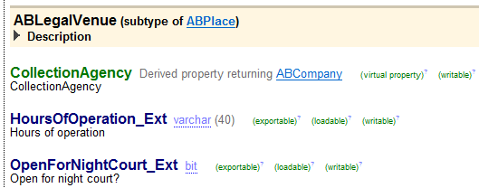

|  |  |
| --- | --- |
|  | Stop and ask your instructor to review your completed lab or compare your solutions with the available solution set. |